Just Right Chiropractic

Injury Questionnaire
Name_________________________ Date: _________________________
On the drawing below, please use the following LETTER ABBREVIATIONS to indicate the location and type of discomfort you are experiencing.

N = Numbness T = Tingling B = Burning
P = Sharp Pain D = Dull Pain S = Stiffness
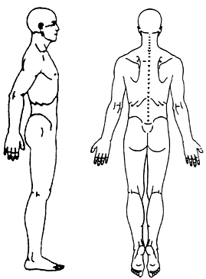
List in order your GREATEST CCONCERN down to your LOWEST CONCERN
- ____________________ 3) ____________________
- ____________________ 4) ____________________

Patient Signature: ________________________________________

